**Central Goldfields Art Gallery Ramp Space 2026**

# Expression of Interest

Central Goldfields Art Gallery (CGAG) invites artists living in Central Goldfields Shire (CGS) as the first priority or close by in adjoining towns as the second priority to apply for an exciting opportunity to showcase their work in CGAG’s Ramp Space as part of the 2026 exhibition program.

**What’s included if you’re selected to exhibit in the Ramp Space**

**(at no cost to you)**

* Inclusion of your exhibition in CGAG's annual exhibition program
* Professional installation of your artwork
* Public exhibition opening event
* Promotion through the CGAG website, social media, and CGAG marketing outlets
* Support for your artistic career and opportunity to sell art on display in your exhibition
* No exhibition hire fee

# About the Ramp Space

The Ramp Space is an elegant, linear gallery space that runs along the central spine of CGAG offering glimpses into the art collection store as well as providing views through a dramatic skylight to the fire tower and sky.

The Ramp Space offers 23.9 linear metres of exhibition walls and 49.4m2 of floor space. The walls consist of masonry walls covered with 13mm plasterboard with painted finish, mounted over 20mm plywood fixed to full height battens (from floor to ceiling).

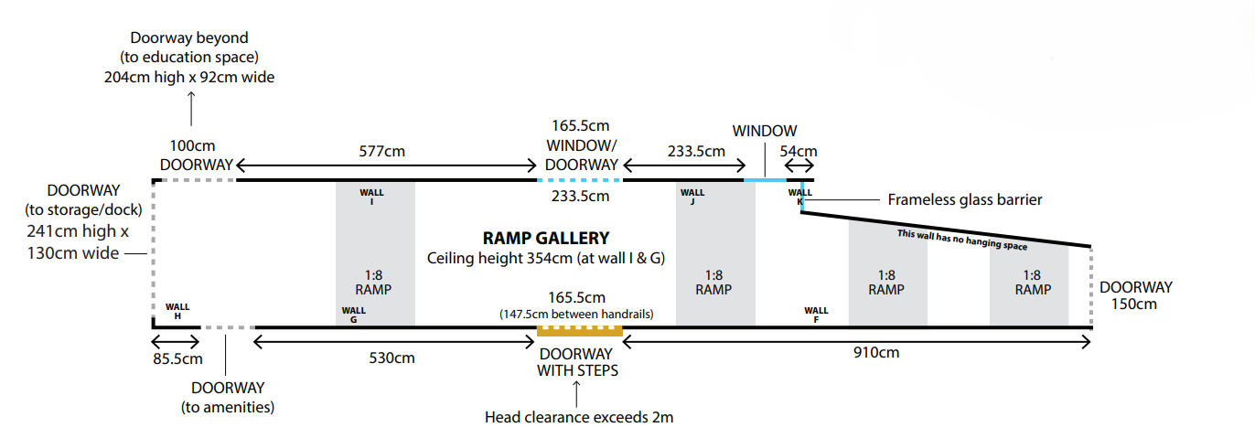

## **Selection Criteria**

Applications will be assessed based on:

* Artistic merit
* Suitability for Ramp Space
* Alignment with the Gallery’s Exhibition Programming Guidelines and compliance with the Ramp Space EOI requirements
* Potential career impact for the artist

## **Key Dates**

**EOI Deadline**: 7 November 2025

**Notification of Outcome:** 28 November 2025

## **Submission Details**

Please submit your completed EOI form and support documentation and submit by email to: cgsc.art@cgoldshire.vic.gov.au

**Preferred file format for email submissions:** Single PDF document (where possible)

**Subject line**: “Ramp Space EOI 2026 – [Your Full Name]”

**Or deliver to**:

Central Goldfields Art Gallery,   
1 Neill St, Maryborough VIC 3465 – note, CGAG is open from 10am to 4pm Thursday to Sunday

## **Expression of Interest Form**

## **Artist Details**

**Full Name:** ________________________________________

**Address:** ________________________________________

**Phone Number:** ________________________________________

**Email:** ________________________________________

**Website / Social media (optional):** ________________________________________

## **About Your Practice – maximum of 150 words**

**Artist biography or CV:**

**Brief description of your artistic practice:**

## **Proposed Exhibition**

**Proposed title of exhibition (if any):**

**Tell us about the work you want to exhibit** (max 150 words):

**Preferred time of year for the proposed exhibition (if any):**

## **Career Impact**

## How would exhibiting in the Ramp Space support your career? (max 150 words)

## **Support Material**

Please attach the following with your application:

* 5 images of recent or proposed work (JPEG or PDF)
* Image list including title, medium, size, year

## **Declaration**

I confirm the information provided is true and correct. I understand that this is an expression of interest only and does not guarantee selection for an exhibition in the CGAG Ramp Space.

**Signature:** ________________________________________

**Date:** ________________________________________

## ***Acknowledgement of Country***

*Central Goldfields Shire Council acknowledges and extends appreciation for the Dja Dja Wurrung People, Traditional Owners of this land. We pay respects to Elders past, present, and emerging — and acknowledge their deep cultural connection to this country.*